LAU WebEx Meeting Quick Start Guide

- Sign in to Cisco WebEx
- Start and Schedule a Meeting using Web Browser
- Download WebEx Desktop App
- Start and Schedule a meeting using WebEx Desktop App
- Start and Schedule a meeting using Outlook Add-In
- Set-up WebEx Call preferences

N.B: Your user profile must be set up for WebEx scheduling in order to schedule meetings through the Cisco WebEx

Sign in to Cisco WebEx

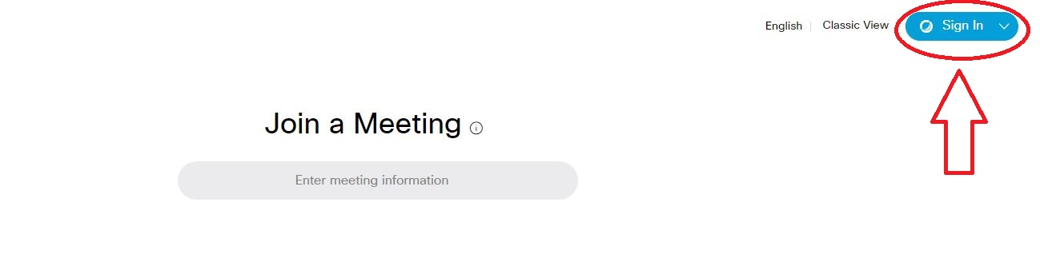
- Open a web browser and enter https://lau.webex.com

- Sign in using your LAU email address

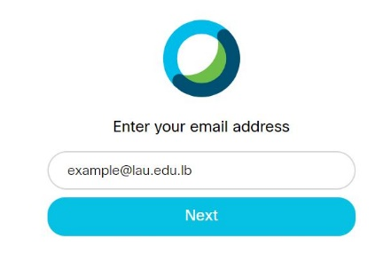

- Enter your username and password, and then select Log In.
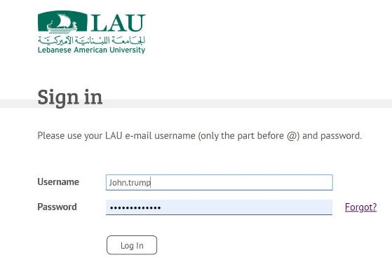

Start and Schedule a Meeting using Web Browser

- To immediately start a meeting, Press Start Meeting on the Home Page.

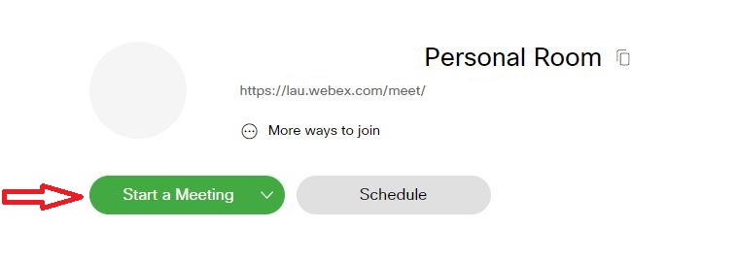

- Invite participants by sending an email with the following link : https://lau.webex.com/meet/username

- To schedule a meeting: press Schedule
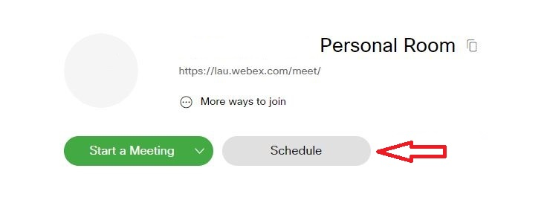

Download WebEx Desktop App:

It is highly recommended to use the WebEx Desktop App for a smoother experience. To download the app:
- In the home page go to “Downloads”
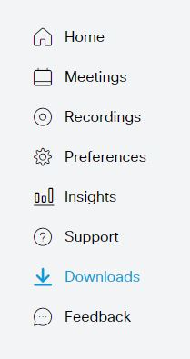
- Desktop App Download

Start and Schedule a Meeting using WebEx Desktop App:

- Open the Desktop App and Start a Meeting
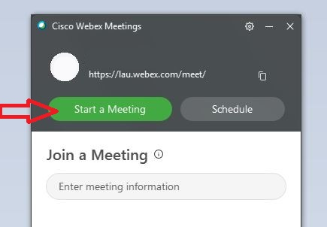

- Invite participants by sending an email with the following link : https://lau.webex.com/meet/username

- To schedule a meeting: Open the Desktop App and click on Schedule
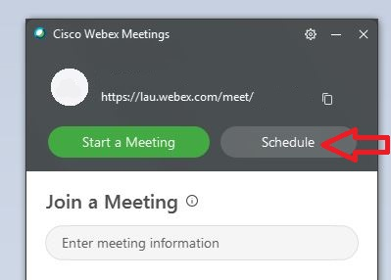

- After you click on Schedule, an automatic Meeting Invitation email will open via Outlook:

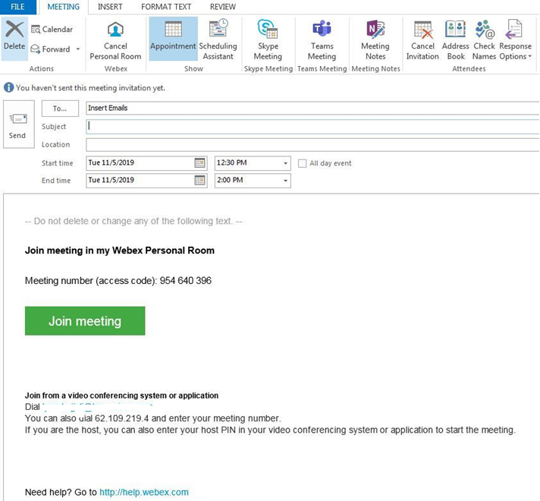

Start and Schedule a Meeting using Microsoft Outlook Add-In:

- To start a meeting, open outlook and press Meet Now:
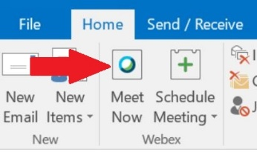

- To schedule a meeting, press Schedule Meeting > Schedule Personal Room Meeting:

Set-up WebEx Call preferences

  - To Connect Using Computer Audio, click on Use computer for Audio
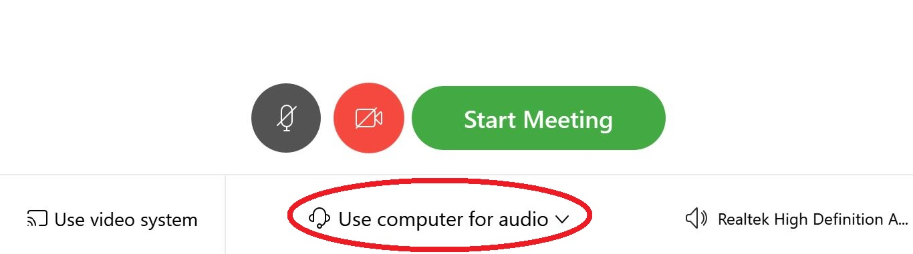

  - Test your Speaker, Microphone and Camera:

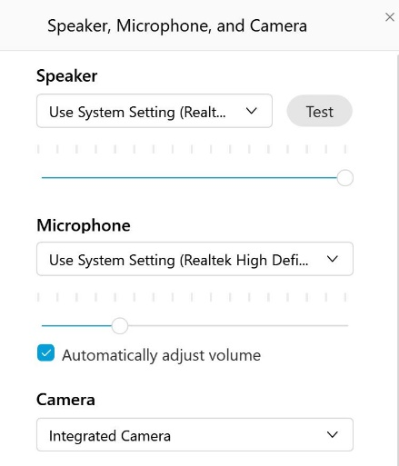

  - After testing audio and video devices, Press Start Meeting.

- To share content during a call, press Content Share and select the proper Screen/App
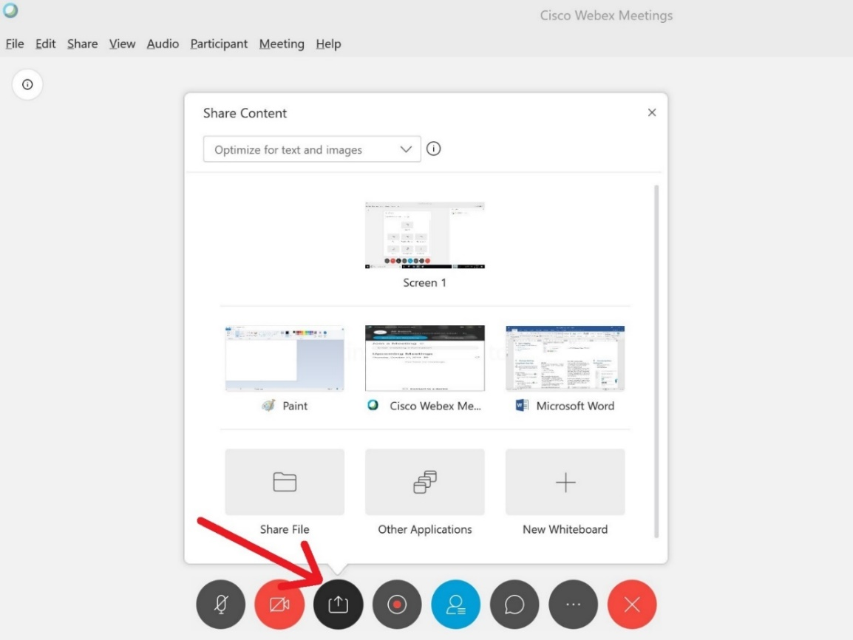

- The Menu options are explained below:
  - Mute Microphone
  - Stop Viewing your Camera
  - Share Content
  - Record a meeting
  - Show the Participant List
  - Chat with Participants
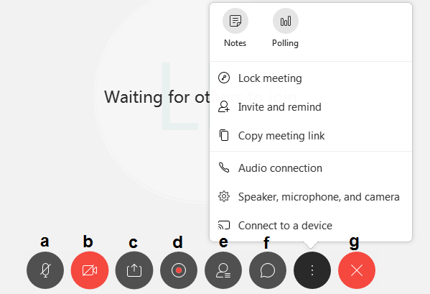
  - End or leave Meeting

