Getting Started with Lecture Capture
Handout 1
Setting up Panopto
- Open Blackboard to your dashboard
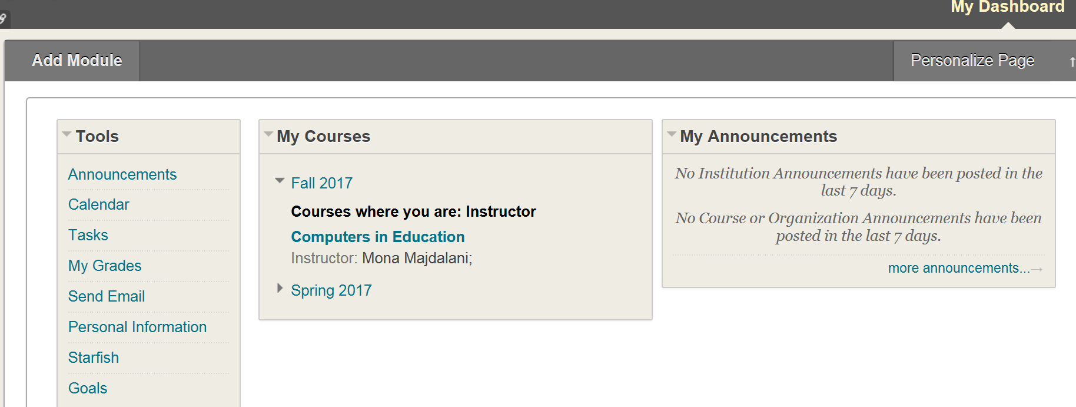

- Under My Courses section, select the course to which you want to add Panopto
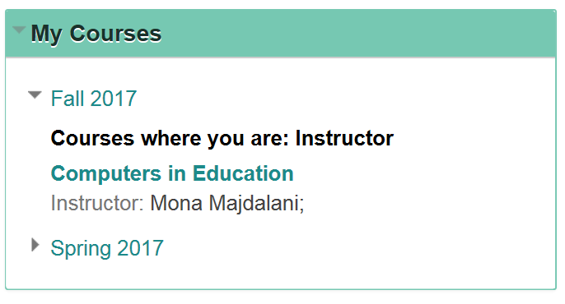
- Double click on it to open it
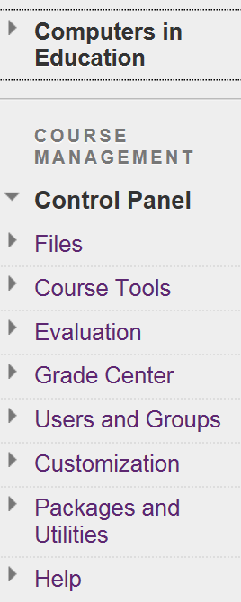

- Under Course Management Control Panel. Select Customization and then go to Tool Availability.

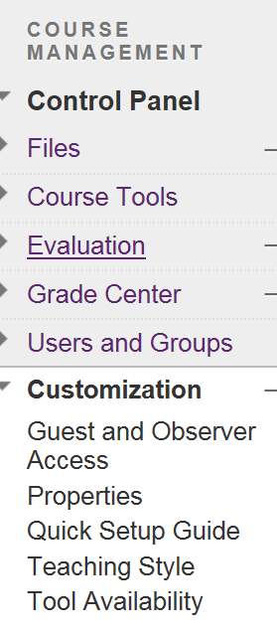

- Scroll down to Panopto, select all three options related to Panopto and click on Submit.
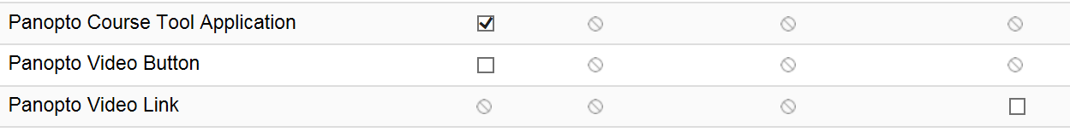
- Go back one level and select + in the upper left corner of your screen, it opens a list of options to pick from, select Tool Link
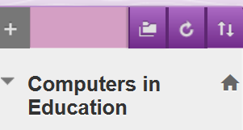

The following window will appear
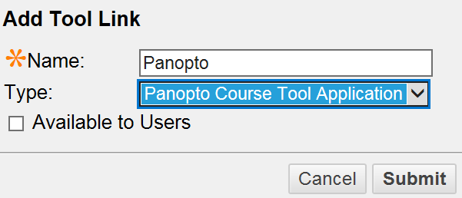
- Write ‘Panopto’ for the Name label, and select ‘Panopto Course Tool Application’ from the Type drop-down box, and click Submit.

- The Panopto name should appear on your list
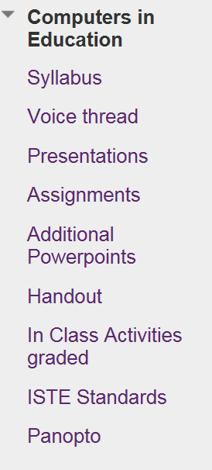

- Now click on Panopto to get started

- The following screen will appear, click configure

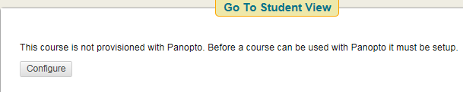

- The following screen will appear, click OK

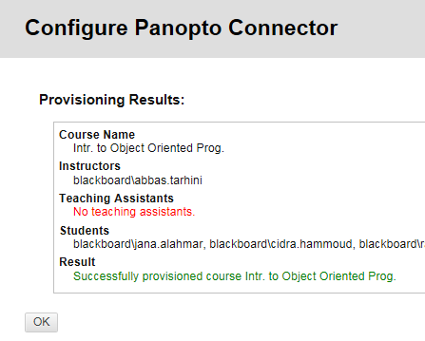

- Select the Course folder, and click submit:
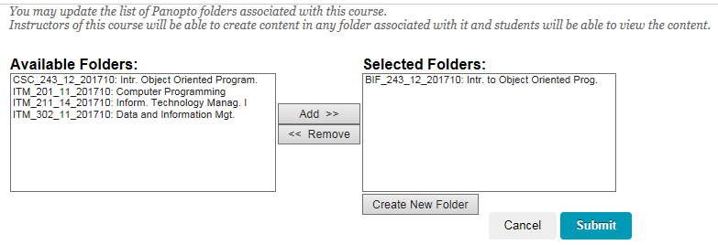

- Click on Create, and select ‘Record a new session’ to start recording:
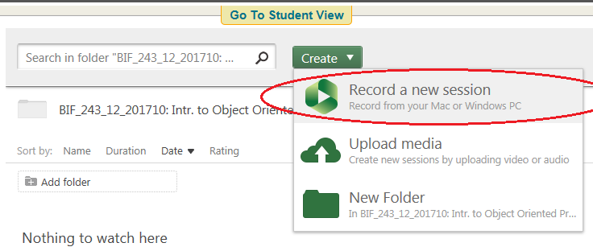
- Panopto window will appear, select ‘Capture PowerPoint’ to include your PowerPoint slides in the recording. Select ‘Capture Main Screen’ to include your computer screen and mouse movements in the recording. Select ‘Add Another Video Source’ to capture ‘Audience’ and/or ‘Instructor’ camera.
Click ‘Record’ to start recording the session.

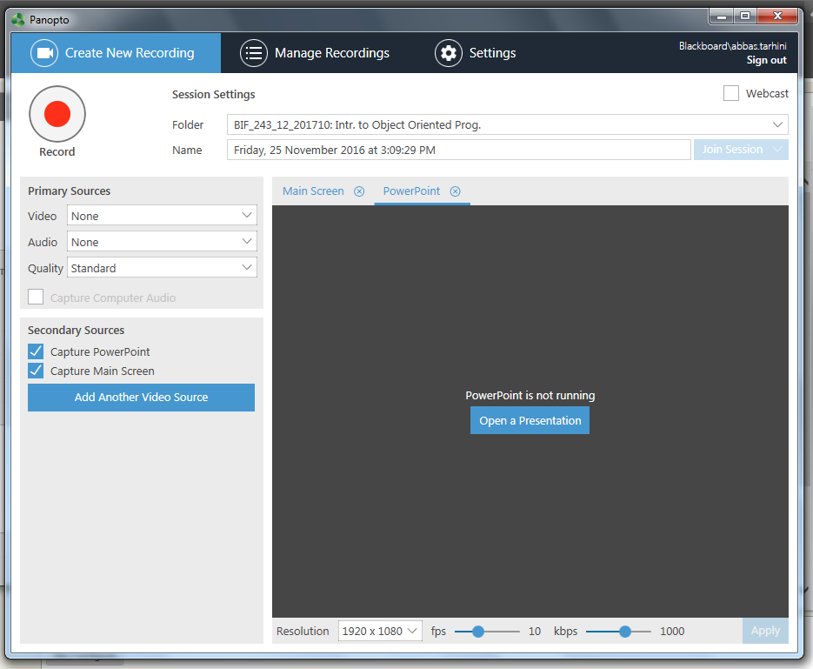

- When recording is stopped, the session will be automatically uploaded into your blackboard. To edit this session, click ‘Edit’

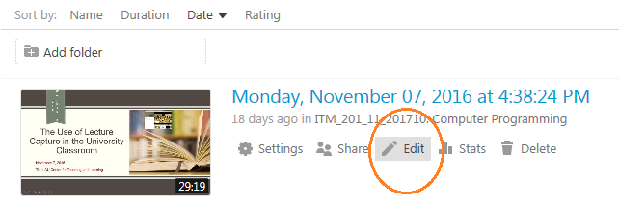

- Select the ‘input source’ you need to trim, then select the ‘Cut 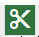’ sign
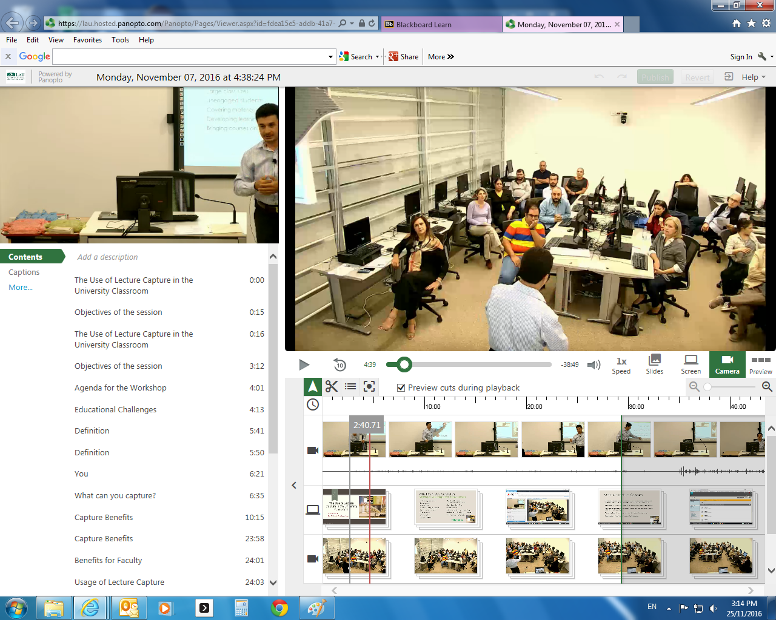

- Move the ‘Trim Bar’ to trim frames that are not needed, then click ‘Publish’. 