Blackboard Learn Instructor Guide – Create Test

Blackboard 9.1 – Create Test
The Tests tool enables you to create assessments using a variety of question types.

Many question types are scored automatically by the system, such as multiple choice, True/False, matching, and fill in the blank. Other question types, such as essay and short answer, require you to manually grade each student's answer.
For each test you create, a column is created automatically in the Grade Center.
- Create Test

    - Click Course Tools in the Control Panel.
    - Click Test, Survey, and Pools.
    - Click Tests.

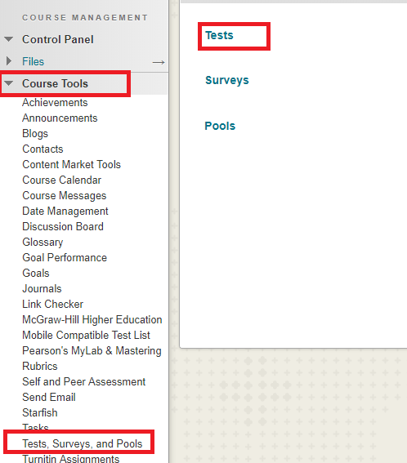

    - Click the Build Test button.

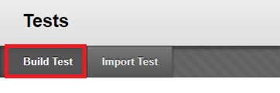
    - Type the name of the test.
    - Add a short description about the test (optional).
This text will be presented to your students before they begin the test.
    - Type the test instructions. This will be presented to students during the test.
    - Click Submit.
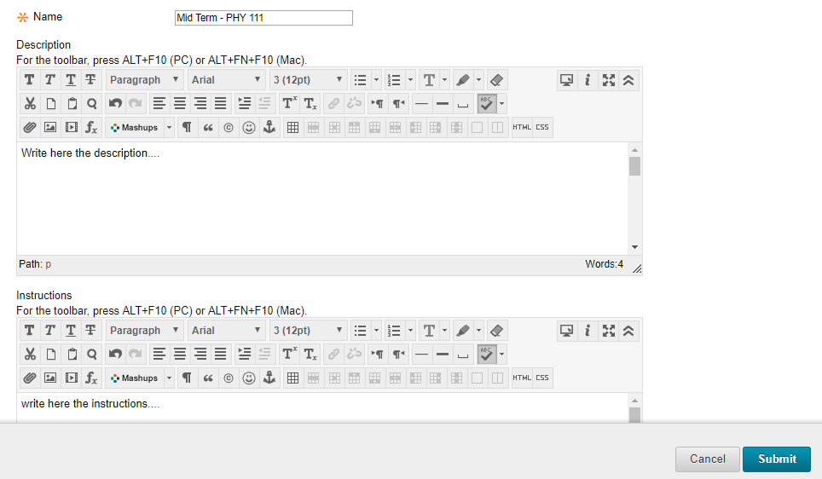
    - Set the default test options including points per question, by selecting Question Settings. Make updates and click Submit.

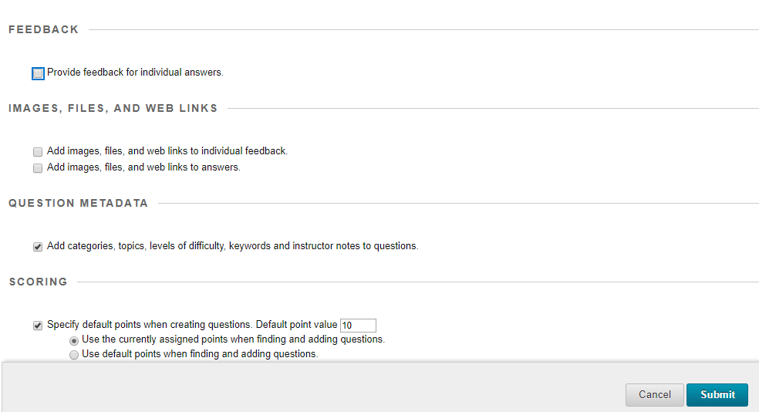

    - Put your cursor on the Create Question button.
    - Use the pull-down menu to select the type of question.
    - Enter the question text and answer(s) depending on the question type.
    - Type feedback for incorrect and correct responses (optional).
    - Click Submit or Submit and Create Another.
    - Click submit.
    - To create additional question, repeat steps 11-15.
    - When finished, click OK.
Creating Multiple Choice Questions
- On the Create Question drop-down list, select Multiple Choice.

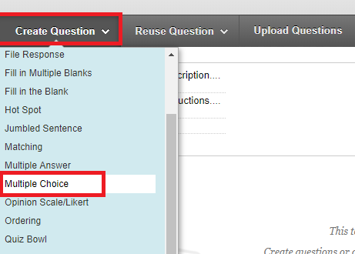

- On the Create/Edit Multiple Choice Question page, enter the Question Text and title. Format the question with the Text Editor, if desired.

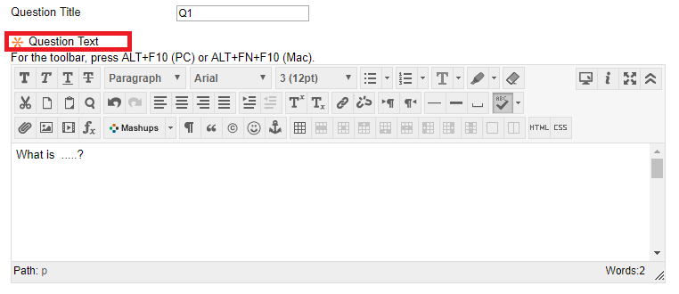

- Select Options, such as how answers are numbered, orientation, and partial credit, if desired.

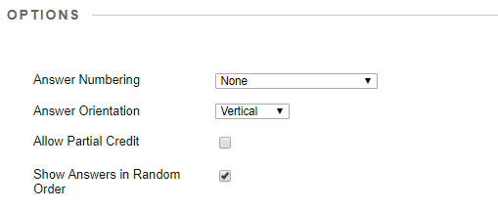
- Select Number of Answers from the drop-down list.

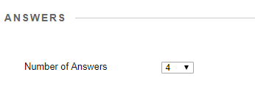
- Enter answers in the Answer boxes.
- Select the radio node for the correct answer.

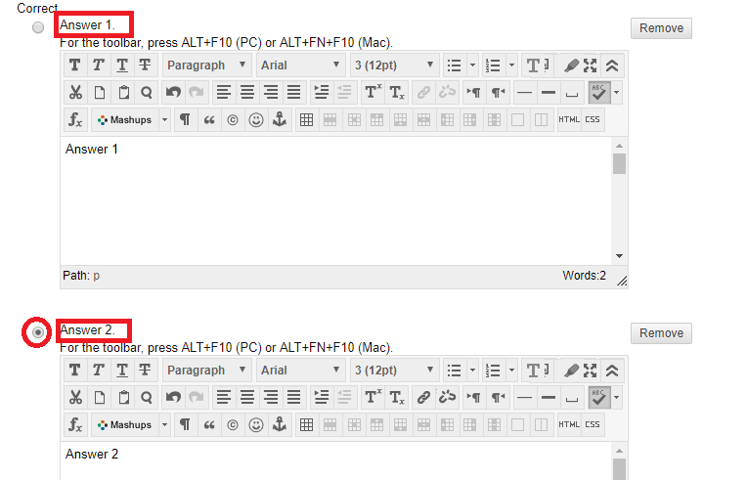
- Optionally, enter Feedback for the correct and incorrect answers.
- You can choose to give the question category, topics, a difficulty, and keywords for sorting later
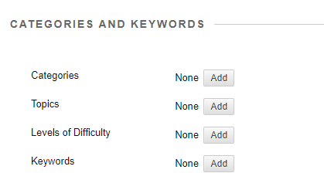
- You can also leave instructor notes for yourself for later.

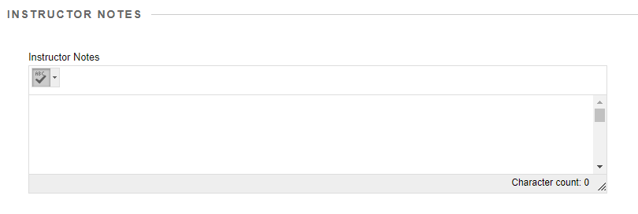

- Deploy a Test

- Navigate to a Content Area.

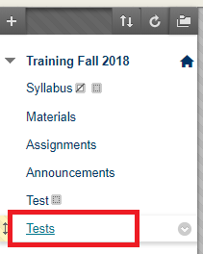

- On the Action Bar, mouse over the Assessments tab.

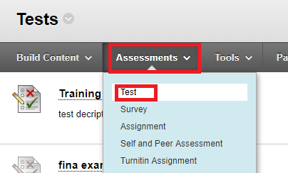

- Select Test.
- On the Create Test page, select a test from the Add Test box.
- Click Submit.

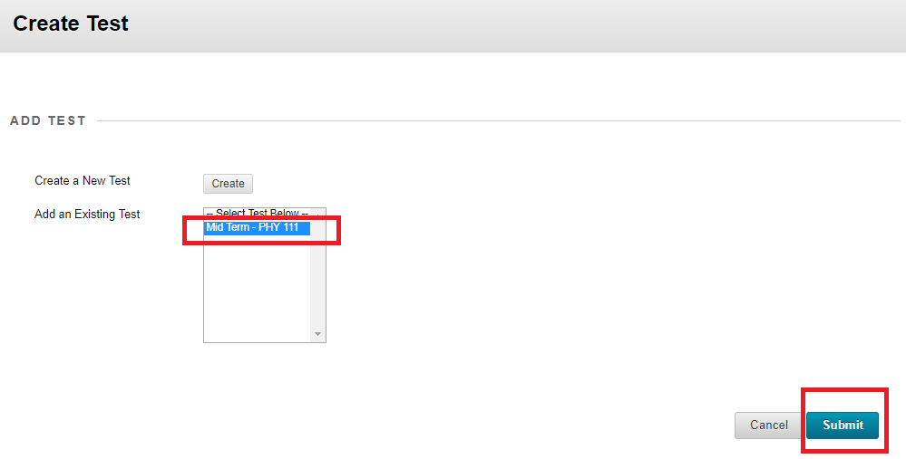

- After an existing test is added to a Content Area, the Test Options page appears.
You will now see a screen labeled Test Options that allows you to set up how the test appears to students. The Test Information section allows you to edit the information that is shown to students in the link for the test.
Setting up the Test Information Settings
- Name: The test can be renamed by entering a new name in this field.
- Choose Color of Name: The color selector will allow you to change the color of the test link.
- Content Link Description: You can type a description of the test in the space here.
- Test Description: The description that was created when setting up the test questions in Blackboard will appear here. If a test description was not created, this item will not appear. To make the description visible to students prior to starting the test, check the box for the option labeled Show Test Description to students before they begin the test.
- Test Instructions: Test instructions that were entered when setting up the test questions in Blackboard will appear here. If test instructions were not entered, this item will not appear. To make the instructions visible to students prior to starting the test, check the box for the option labeled Show Instructions to students before they begin the test.
- Open Test in New Window: Select Yes to open the test in a new window, or select No to open the test in the same window (optional)
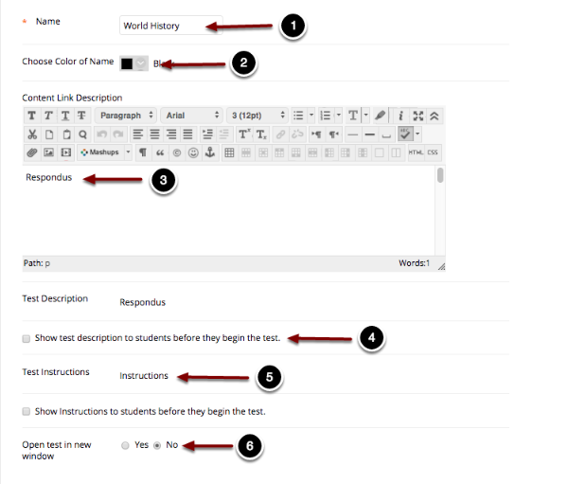

Setting Up the Test Availability and Timer

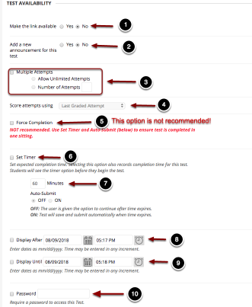

Test Availability allows you to modify the number of attempts students have to take the test, the test timer settings, and the test availability settings.
- Make the Link Available: Select Yes to make the test visible to students. Note: If the test availability is set to No, students will not be able to access the test, even if the test availability dates are specified.
- Add a New Announcement: Select Yes to automatically generate a message that the test has been posted. (If you want a more detailed message, it is recommended to create your own announcement.)
- Multiple Attempts: Check the box to allow for multiple attempts, and select either to Allow Unlimited Attempts or select Number of Attempts and enter the number of attempts allowed. Leave this option unchecked for a single attempt.
- Score Attempts Using: If you have selected the option to allow multiple attempts, this dropdown menu will allow you to select how to grade multiple attempts (Last graded attempt, Highest grade, Lowest grade, First graded attempt, Average of graded attempts).
- Force Completion: Enabling this option will prevent students from reentering the test if they exit the test without submitting. If students encounter technical problems, then they would not be able to reenter the exam. This option is NOT RECOMMENDED. To ensure students complete the test within the test time limit, please enable the timer and turn Auto Submit on.
- Set Timer: Check the box to enable a time limit for the test, and enter the duration in minutes: The maximum duration is 300 minutes (five hours).
- Auto-Submit: Select On to enable Auto Submit, in which the test will automatically submit after the timer ends. The timer will run continuously, regardless of whether or not the student is in the test at that moment. If you select Off, students can continue past the time limit, but the time is noted in the grade center.
- Display After: Check the box and use the date and time pickers to select the date in which the test would become available to students.
- Display Until: Check this box and use the date and time pickers to select the date in which the test is no longer available to students. After the specified date, the test is no longer visible to students, and students can no longer access the test.
- Password: To enforce requirements for students to take the exam in a classroom or proctored environment, check this box and enter the desired password that would be distributed to proctors and entered prior to the student starting the test.
Warning: Enabling Force Completion is Not Recommended. This option will prevent students from reentering the test in the event of a technical difficulty. In order to ensure completion of the test within the time limit, it is recommended to set the timer and turn Auto-Submit on.

Setting up the Test Availability Exceptions
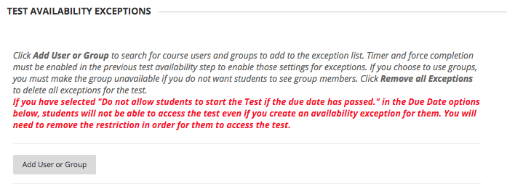
Test Availability Exceptions allows users to specify students or groups to provide exceptions to the availability settings listed above. Options for Test Availability Exceptions include the following: Timer, Auto Submit, Number of Attempts, Availability, and Force Completion. To set up availability exceptions, click the Add User or Group button.
Setting up the Due Date

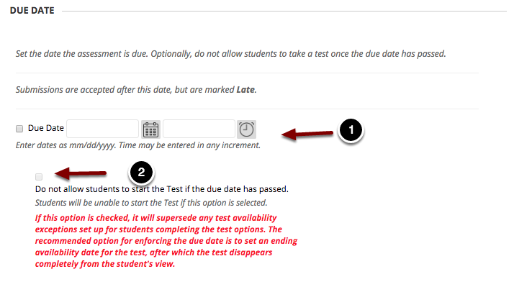
Due Date allows you to specify a due date for the assignment that will show up in the student's calendar, as well as in the instructor's Grade Center. The due date option does not restrict the student's ability to submit after the due date has passed, and items submitted after the due date would be marked as Late
- Due Date: Use the time and date pickers to set up the due date for the item.
- Do not allow students to start the Test if the due date has passed: This option will prevent students from beginning the test after the due date has passed. If this option is checked, it will supersede any test availability exceptions set up for students completing the test options.
The recommended option for enforcing the due date is to set an ending availability date for the test, after which the test disappears completely from the student's view.
Setting up Grading Options
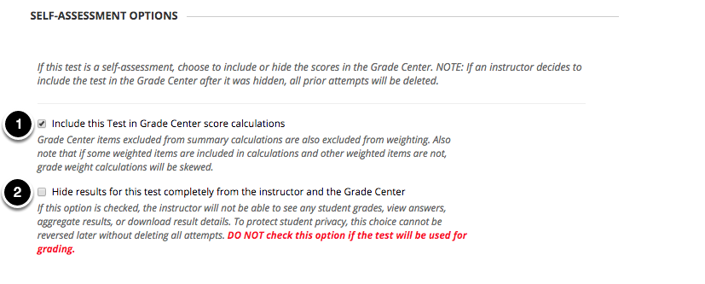
Self-assessment Options determines how Blackboard handles the scoring of the exam in relation to the Grade Center grade calculations.
- Include this Test in Grade Center Score Calculations: Check the first checkbox to include the test in Grade Center calculations.
- Hide Results for this Test Completely from Instructor and the Grade Center: DO NOT check the second option if you are using the test for grading. If you select this option, you will not be able to access the assessment results, and student attempts will be deleted if this option is reversed.

Setting up Test feedback Options
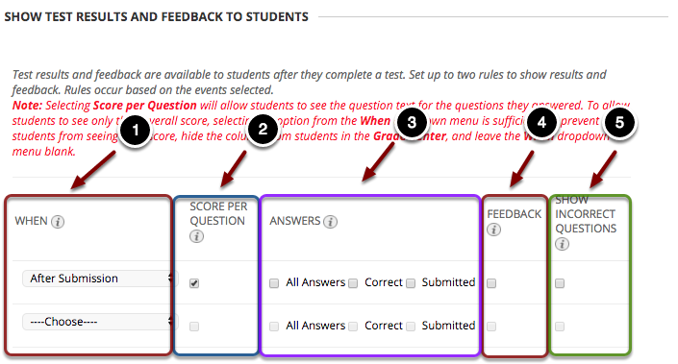
Show Test Results and Feedback to Students allows instructors to determine what type of feedback students are able to view. Instructors can set up to two rules for displaying feedback to students. A selection is required for the first rule, but the second rule is optional. Note: if you do not want students to see the assessment score at all, you would need to hide the column associated with the test in the Grade Center from students ‘view.
- When: Use the dropdown menu to specify when students can view specific feedback for each rule: The options for the first rule include After Submission, One Time view, On Specific Date, After Due Date, After Availability End Date, and After All Attempts are Graded. The options for the second rule include On Specific Date, After Due Date, After Availability End Date, and After All Attempts are Graded. Note: The After All Attempts are Graded option is not recommended, as Blackboard will only release the feedback after every student listed in the course has taken the exam, including the instructor's student account, students marked as unavailable, and students who have dropped the course.
- Score per Question: Checking this option will allow students to see the test questions and their score for each question. Note: To allow students to see only their overall score, selecting an option from the When dropdown menu is sufficient. To prevent students from seeing their score, hide the column from students in the Grade Center, and leave the When dropdown menu blank.
- Answers: Instructors can check whether students can see all answer choices, the correct answer choices, as well as the choices the students submitted.
- Feedback: Checking this option allows students to view question-specific feedback that was entered when creating questions in Blackboard. if the instructor is providing feedback for essay questions, this option must be checked in order for student to view the feedback the instructor has provided.
- Show Incorrect Questions: Checking this option will allow students to see which items were marked as incorrect.
Setting Up the Test Presentation
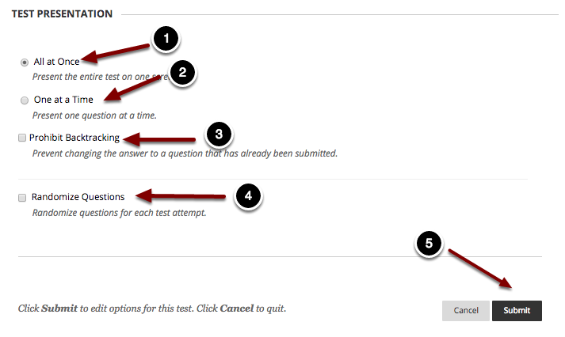
Test Presentation allows you to choose how the test is presented to students:
- All at Once: Choose this option to present the test all at once to students on one screen.
- One at a Time: Choose this option to present one question at a time to students.
- Prohibit Backtracking: Checking this option will prevent students from going back to previous questions they have answered.
- Randomize Questions: Checking this option will display the questions in random order for each attempt.
- When finished, click the Submit button at the bottom of the page to save the test settings and make the exam available to students.
Preview a Test
This allows the instructor to take a test but does not record results in the Grade Center. (An alternative method is to use Student Preview mode to take the test.
After taking the test when you exit Student Preview mode, select keep the preview user and all data if you want to view the test grade in the Grade Center.)
- Navigate to the content area where the test is deployed.
- Click the test name.
- Select the Begin button.
Modify the Settings for a test
- Navigate to the content area where the test is deployed.
- Put your cursor on the test name.
- Click the options menu (gray circle) to the right of the test name.

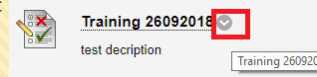

- Select Edit the Test Options.

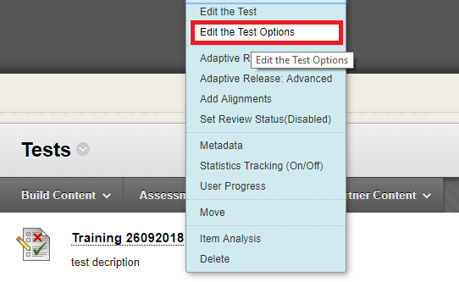

Viewing and Grading a Student's Test Attempt
How can you access a student's test attempt in Blackboard in order to view and grade the attempt?

Accessing the Grade Center
- Go to the Control Panel
- Click on Grade Center.
- Select Full Grade Center.
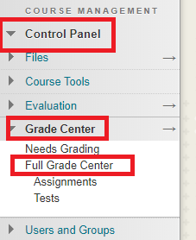

Accessing a Student's Test Attempt
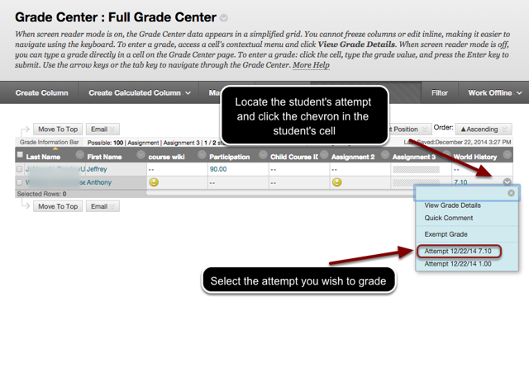
Within the grade center, locate the student and the column for the test. Hover in the cell that contains the student's attempt, and click on the chevron that appears. Select the attempt you wish to view from the menu that pops up. A yellow exclamation (!) point indicates that the student's attempt needs grading. A Needs Grading icon will appear for a student's test attempt under the following conditions:
- The test contains Essay or other question types that require manual grading.
- The student went over the allotted time limit, or the test was auto-submitted when the student ran out of time.
- The test was submitted past the due date.
Viewing and Grading the student's attempt
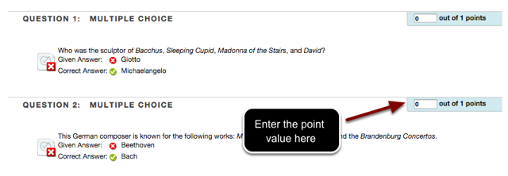
You will now see the student's responses to the test questions. Questions such as multiple choice, true/false, and fill in the blank will be graded automatically by Blackboard. Essay questions must be manually graded by the instructor or grader. To enter or change the earned points for the student's attempt, type in the point value in the points box to the right of the question. Essay questions also provide a space for feedback to the student.
Entering Feedback and Grading Notes
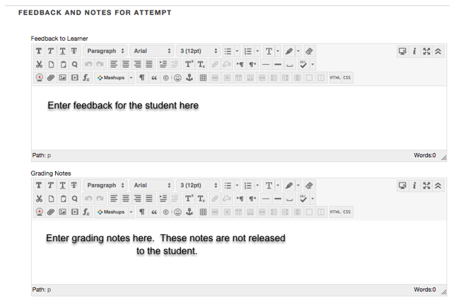
The section labeled Feedback and Notes for Attempt provides a space for the instructor or grader to enter comments to the student, as well as notes for the instructor that are not released to the student.
To write a comment for the student, type the feedback in the text box labeled Feedback to User.
To write comments for the instructor's use only, type the comment in the text box labeled Grading Notes.
Submitting the Student's Attempt
When finished grading, scroll down to the bottom of the page. To save the student's grade and return to the Grade Center, click the Save and Exit button. To save the grade and move to the next student or the next attempt, click Save and Next. To exit without saving, click Exit.

