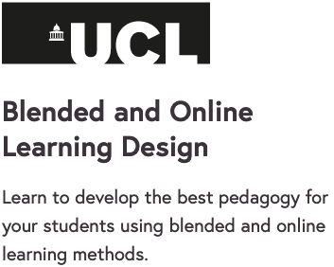

Launches on Monday 11 January on FutureLearn

Develop the skills you need to teach blended and online learning
Online learning is the future of teaching. This three-week teaching course aims to support teachers’ own innovations in teaching and learning online, whether you teach in a school, college or university. It creates the opportunity for a collaborative exchange of ideas, solutions, and learning designs.

See what’s possible with digital technologies and online learning methods
You’ll study both blended and wholly online learning, and will explore the Conversational Framework concept: the idea that the teaching-learning process is an interactive exchange of concepts and practice, using the ideas of social construction and collaborative learning.
You’ll explore a range of digital tools and resources, including the Learning Designer tool, a free online tool to help teachers and lecturers design in-class and online learning activities and share their learning designs across all subjects.

Optimise both blended and online learning methods for your students
Through using this tool, you’ll see how to improve synchronous and asynchronous learning, and explore how to use videos, forums, creative tools, and quizzes, and to bring a selection of digital tools into your teaching techniques.

Learn from teaching experts at UCL Institute of Education (IOE) and the community
UCL-IOE is rated as the number one education faculty in the world university rankings, and provides expertise in teaching and educational research across all sectors, primary to higher education, and across all main subject areas. We have collaborated with teachers from all sectors to develop this course-collaboration.

What topics will you cover?
- The nature of learning design in the context of blended and online learning
- The Conversational Framework as a tool for thinking about learning design and assessment
- Digital tools and resources to enhance your learning management system
- The Learning Designer tool for borrowing, planning, creating and sharing designs
- Learning designs and types of formative assessment for blended and online learning
- Implementing online learning across your institution

